

ccc
Since 2025
Pure. Proven. Global

Product Sheet – Teja S17 Red Chilli

🌶️ Product Overview

Product Name: Teja S17 Dry Red Chilli
HS Code: 09042110 (Capsicum / Dried Red Chillies)
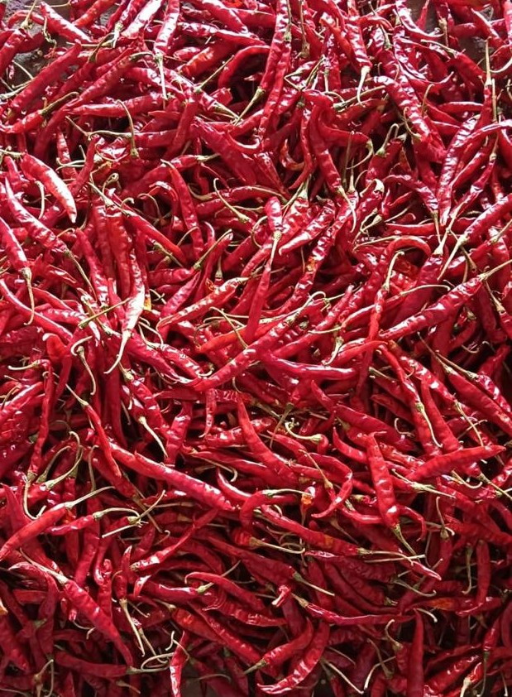
Teja S17 is one of the spiciest and most sought-after chilli varieties from Andhra Pradesh, India. Known for its fiery heat, sharp flavor, and vibrant red color, Teja is widely used in spice blends, sauces, and cuisines that demand high pungency.

🔑 Key Specifications

• ASTA Colour: 70–110
• SHU (Heat): 45,000 – 75,000
• Moisture: ≤ 12%
• Admixture: ≤ 2%
• Aflatoxin: < 5 ppb (as per EU standards)
• Forms Available: Whole, Stemless, Stem-cut, Powder, Flakes
• Processing: Sun-dried, machine-cleaned, hand-sorted

📊 Varnya Grading System

Grade | Heat (SHU) | Color (ASTA) | Moisture (%) | Best For
VX-Premium | 65,000–75,000 | 90–110 | ≤ 10% | Premium spice blends, gourmet markets, high-heat cuisines
VX-Select | 55,000–65,000 | 80–90 | ≤ 11% | Balanced flavor & color, mainstream spice brands
VX-Value | 45,000–55,000 | 70–80 | ≤ 12% | Budget-friendly, bulk processing, powders & flakes

📦 Packaging Options
• 5 kg, 10 kg, 25 kg PP / Jute / Paper Bags
• Vacuum packs for powders & flakes
• Palletized bulk packaging for export containers
• Private label & custom branding available

🧾 Certifications & Compliance
✔️ FSSAI Licensed
✔️ Spice Board RCMC – CRES
✔️ IEC, GST, LUT Compliant
✔️ Lab-tested for moisture, color, aflatoxin, and microbiological safety
✔️ COA (Certificate of Analysis) available on request

🚢 Export Readiness
• Incoterms: FOB / CIF / EXW available
• MOQ: 2–3 MT per grade (customizable for trial orders)
• Lead Time: 10–15 days ex-factory after PO
• Ports: Chennai, Krishnapatnam, Vizag
• Transit Time: 7–14 days (UAE / Singapore)

🧾 Lab Report
Available on request (can be shared with buyer upon inquiry).

📩 Contact
Varnya Exports
📧 info@varnyaexports.com
📞 +91-9100913708
🌐 www.varnyaexports.com

