

ccc
Since 2025
Pure. Proven. Global

Product Sheet – TGEB Pepper

🌶️ Product Overview

Product Name: Tellicherry Garbled Extra Bold (TGEB) Black Pepper
HS Code: 09041130 (Black Pepper, whole)
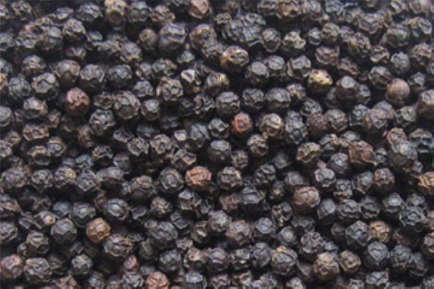
TGEB is considered the finest grade of Indian pepper, handpicked from Kerala plantations. Known for its extra bold berries (>4.25 mm), rich aroma, and high piperine content, it is highly prized in gourmet markets worldwide.

🔑 Key Specifications

• Piperine: 5–7%
• Moisture: ≤12%
• Admixture: ≤0.5%
• Berry Size: ≥4.25 mm
• Density: ≥600 g/l
• Forms Available: Whole, Powder, Crushed
• Processing: Sun-dried, machine-cleaned, hand-garbled, sortex-cleaned

📊 Varnya Grading System

Grade | Piperine(%) | Size/Density | Moisture (%) | Best For
VX-Premium | 6.5–7% | ≥4.25 mm / ≥600 g/l | ≤ 10% | Gourmet spice houses, premium EU/US buyers
VX-Select | 5.5–6.5% | ≥4.25 mm / 590–600 g/l | ≤ 11% | Mid-tier spice brands
VX-Value | 5.0–5.5% | ≥4.0 mm / 580–590 g/l | ≤ 12% | Budget blends, bulk powders

📦 Packaging Options
• 25 kg / 50 kg PP / Jute bags
• Vacuum packs for powders
• Private label & custom branding available

🧾 Certifications & Compliance
✔️ FSSAI Licensed
✔️ Spice Board RCMC – CRES
✔️ IEC, GST, LUT Compliant
✔️ COA (Piperine, moisture, microbiological) available on request

🚢 Export Readiness
• Incoterms: FOB / CIF / EXW available
• MOQ: 3–5 MT per grade (customizable for trial orders)
• Lead Time: 10–20 days ex-factory after PO
• Ports: Cochin, Mangalore
• Transit Time: 7–14 days (UAE / Singapore)

🧾 Lab Report
Available on request (can be shared with buyer upon inquiry).

📩 Contact
Varnya Exports
📧 info@varnyaexports.com
📞 +91-9100913708
🌐 www.varnyaexports.com

