

ccc
Since 2025
Pure. Proven. Global

Product Sheet – Guntur Sannam Red Chilli

🌶️ Product Overview

Product Name: Guntur Sannam S4/334 Dry Red Chilli
HS Code: 09042110 (Capsicum / Dried Red Chillies)
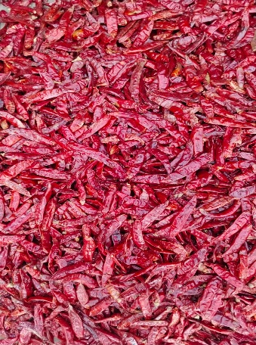
Guntur Sannam S4/334 is India’s most exported chilli variety, prized for its balanced pungency, deep red colour, and consistent quality. Perfect for curry powders, pickles, sauces, and spice blends.

🔑 Key Specifications

• ASTA Colour: 40–80
• SHU (Heat): 15,000 – 35,000
• Moisture: ≤ 12%
• Admixture: ≤ 2%
• Aflatoxin: < 5 ppb (as per EU standards)
• Forms Available: Whole, Stemless, Stem-cut, Powder, Flakes
• Processing: Sun-dried, machine-cleaned, hand-sorted

📊 Varnya Grading System

Grade | Heat (SHU) | Color (ASTA) | Moisture (%) | Best For
VX-Premium | 25,000–35,000 | 60–80 | ≤ 10% | High-end spice blenders, gourmet retail
VX-Select | 20,000–30,000 | 50–60 | ≤ 11% | Powder mills, masala brands, everyday culinary use
VX-Value | 15,000–25,000 | 40–50 | ≤ 12% | Budget-friendly, bulk processing, powders & flakes

📦 Packaging Options
• 5 kg, 10 kg, 25 kg PP / Jute / Paper Bags
• Vacuum packs for powders & flakes
• Palletized bulk packaging for export containers
• Private label & custom branding available

🧾 Certifications & Compliance
✔️ FSSAI Licensed
✔️ Spice Board RCMC – CRES
✔️ IEC, GST, LUT Compliant
✔️ Lab-tested for moisture, color, aflatoxin, and microbiological safety
✔️ COA (Certificate of Analysis) available on request

🚢 Export Readiness
• Incoterms: FOB / CIF / EXW available
• MOQ: 3–5 MT per grade (customizable for trial orders)
• Lead Time: 10–15 days ex-factory after PO
• Ports: Chennai, Krishnapatnam, Vizag
• Transit Time: 7 –14 days (UAE / Singapore)

🧾 Lab Report
Available on request (can be shared with buyer upon inquiry).

📩 Contact
Varnya Exports
📧 info@varnyaexports.com
📞 +91-9100913708
🌐 www.varnyaexports.com

