

ccc
Since 2025
Pure. Proven. Global

Product Sheet – Erode Turmeric Fingers

🌶️ Product Overview

Product Name: Erode Turmeric Fingers
HS Code: 09103010 (Turmeric – Curcuma longa)
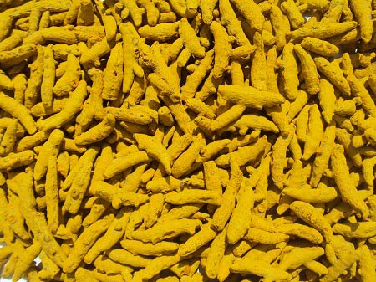
Erode turmeric, grown in Tamil Nadu, is famous for its bright yellow colour and high curcumin content. Widely used in culinary blends, medicinal formulations, and value-added turmeric products.

🔑 Key Specifications

• Curcumin: 3–4%
• Colour (ASTA): 120–180
• Moisture: ≤ 12%
• Admixture: ≤ 2%
• Aflatoxin: < 5 ppb (as per EU standards)
• Forms Available: Whole Fingers, Bulbs, Powder
• Processing: Boiled, dried, polished, machine-cleaned

📊 Varnya Grading System

Grade | Curcumin (%) | Color (ASTA) | Moisture (%) | Best For
VX-Premium | 4%+ | 150-180 | ≤ 10% | Nutraceuticals, premium blends, curcumin extraction
VX-Select | 3-4% | 135-150 | ≤ 11% | Culinary powders, spice blends
VX-Value | 2-3% | 120-135 | ≤ 12% | Budget powders, bulk processing

📦 Packaging Options
• 25 kg / 50 kg PP / Jute bags
• Vacuum packs for powders
• Palletized bulk packaging for export containers
• Private label & custom branding available

🧾 Certifications & Compliance
✔️ FSSAI Licensed
✔️ Spice Board RCMC – CRES
✔️ IEC, GST, LUT Compliant
✔️ COA (Curcumin, moisture, aflatoxin) available on request

🚢 Export Readiness
• Incoterms: FOB / CIF / EXW available
• MOQ: 3-5 MT per grade (customizable for trial orders)
• Lead Time: 10–20 days ex-factory after PO
• Ports: Chennai, Tuticorin
• Transit Time: 7–14 days (UAE / Singapore)

🧾 Lab Report
Available on request (can be shared with buyer upon inquiry).

📩 Contact
Varnya Exports
📧 info@varnyaexports.com
📞 +91-9100913708
🌐 www.varnyaexports.com

