

ccc
Since 2025
Pure. Proven. Global

Product Sheet – Byadgi Red Chilli

🌶️ Product Overview

Product Name: Byadgi Dry Red Chilli
HS Code: 09042110 (Capsicum / Dried Red Chillies)
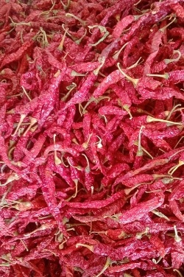
Byadgi chilli, mainly grown in Karnataka, is renowned for its deep red colour, wrinkled appearance, and mild pungency. Rich in natural colour, it is widely used in oleoresin extraction, curry powders, and spice blends.

🔑 Key Specifications

• ASTA Colour: 100–160
• SHU (Heat): 8,000 – 15,000
• Moisture: ≤ 12%
• Admixture: ≤ 2%
• Aflatoxin: < 5 ppb (as per EU standards)
• Forms Available: Whole, Stemless, Stem-cut, Powder, Flakes
• Processing: Sun-dried, machine-cleaned, hand-sorted

📊 Varnya Grading System

Grade | Heat (SHU) | Color (ASTA) | Moisture (%) | Best For
VX-Premium | 12,000–15,000 | 130–160 | ≤ 10% | Oleoresin extraction, high-colour spice blends
VX-Select | 10,000–13,000 | 115–130 | ≤ 11% | Curry powders, masala brands
VX-Value | 8,000–11,000 | 100-115 | ≤ 12% | Budget-friendly spice blends, bulk use

📦 Packaging Options
• 5 kg, 10 kg, 25 kg PP / Jute / Paper Bags
• Vacuum packs for powders & flakes
• Palletized bulk packaging for export containers
• Private label & custom branding available

🧾 Certifications & Compliance
✔️ FSSAI Licensed
✔️ Spice Board RCMC – CRES
✔️ IEC, GST, LUT Compliant
✔️ Lab-tested for moisture, color, aflatoxin, and microbiological safety
✔️ COA (Certificate of Analysis) available on request

🚢 Export Readiness
• Incoterms: FOB / CIF / EXW available
• MOQ: 2–3 MT per grade (customizable for trial orders)
• Lead Time: 10–15 days ex-factory after PO
• Ports: Mangalore, Chennai
• Transit Time: 7–14 days (UAE / Singapore)

🧾 Lab Report
Available on request (can be shared with buyer upon inquiry).

📩 Contact
Varnya Exports
📧 info@varnyaexports.com
📞 +91-9100913708
🌐 www.varnyaexports.com

