

ccc
Since 2025
Pure. Proven. Global

Product Sheet – Bold Cumin Seeds

🌶️ Product Overview

Product Name: Bold Cumin Seeds (Unjha, Gujarat)
HS Code: 09093129 (Cumin, whole – Jeera)
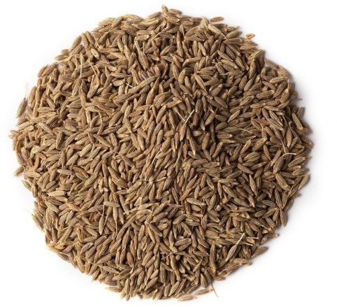

Bold cumin from Unjha, Gujarat, is prized for its larger grain size, strong aroma, and high essential oil content. Widely used in premium spice blends, seasoning, and traditional medicines.

🔑 Key Specifications

• Volatile Oil: 2.5–4.0%
• Purity: ≥99%
• Moisture: ≤10%
• Admixture: ≤1%
• Salmonella / E. coli: Absent
• Forms Available: Whole seeds, Powder
• Processing: Machine-cleaned, gravity-separated, sortex-cleaned

📊 Varnya Grading System

Grade | Volatile Oil (%) | Purity | Moisture (%) | Best For
VX-Premium | 3.5–4.0% | ≥99.5% | ≤ 8% | High-value spice blends, exports to EU/US, pharma
VX-Select | 3.0–3.5% | ≥99% | ≤ 9% | Mainstream spice brands, mid-tier buyers
VX-Value | 2.5–3.0% | ≥98.5% | ≤ 10% | Bulk processing, powders, budget markets

📦 Packaging Options
• 25 kg / 50 kg PP / Jute bags
• Vacuum packs for powders
• Palletized bulk packaging for export containers
• Private label & custom branding available

🧾 Certifications & Compliance
✔️ FSSAI Licensed
✔️ Spice Board RCMC – CRES
✔️ IEC, GST, LUT Compliant
✔️ COA (volatile oil, microbiological, aflatoxin) available on request

🚢 Export Readiness
• Incoterms: FOB / CIF / EXW available
• MOQ: 5 MT per grade (customizable for trial orders)
• Lead Time: 10–20 days ex-factory after PO
• Ports: Mundra, Pipavav
• Transit Time: 7–14 days (UAE / Singapore)

🧾 Lab Report
Available on request (can be shared with buyer upon inquiry).

📩 Contact
Varnya Exports
📧 info@varnyaexports.com
📞 +91-9100913708
🌐 www.varnyaexports.com

