

ccc
Since 2025
Pure. Proven. Global

Product Sheet – Alleppey Turmeric

🌶️ Product Overview

Product Name: Alleppey Turmeric (Kerala)
HS Code: 09103010 (Turmeric – Curcuma longa)
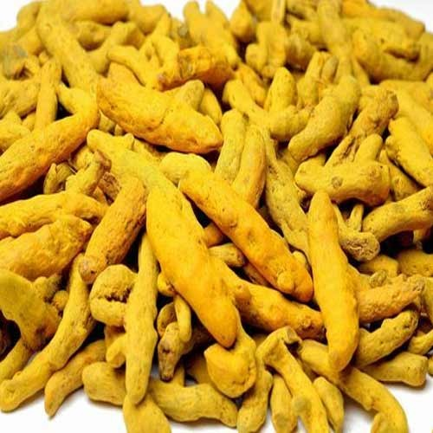
Alleppey turmeric is valued worldwide for its deep orange-yellow colour, high oil content, and distinct flavour. Preferred for exports to US and EU markets for culinary and medicinal uses.

🔑 Key Specifications
• Curcumin: 5–6%
• Colour (ASTA): 150–200
• Moisture: ≤ 12%
• Admixture: ≤ 2%
• Aflatoxin: < 5 ppb (as per EU standards)
• Forms Available: Whole Fingers, Bulbs, Powder
• Processing: Boiled, dried, polished, machine-cleaned

📊 Varnya Grading System

Grade | Curcumin (%) | Color (ASTA) | Moisture (%) | Best For
VX-Premium | 5.5-6% | 180-200 | ≤ 10% | Premium nutraceuticals, high-end culinary powders
VX-Select | 5.0-5.5% | 160-180 | ≤ 11% | Export spice blends, natural food colour
VX-Value | 5.0% | 150-160 | ≤ 12% | Bulk powders, bulk buyers

📦 Packaging Options
• 25 kg / 50 kg PP / Jute bags
• Vacuum packs for powders
• Palletized bulk packaging for export containers
• Private label & custom branding available

🧾 Certifications & Compliance
✔️ FSSAI Licensed
✔️ Spice Board RCMC – CRES
✔️ IEC, GST, LUT Compliant
✔️ Lab-tested for moisture, color, aflatoxin, and microbiological safety
✔️ COA (Certificate of Analysis) available on request

🚢 Export Readiness
• Incoterms: FOB / CIF / EXW available
• MOQ: 3-5 MT per grade (customizable for trial orders)
• Lead Time: 10–20 days ex-factory after PO
• Ports: Cochin, Tuticorn
• Transit Time: 7–14 days (UAE / Singapore)

🧾 Lab Report
Available on request (can be shared with buyer upon inquiry).

📩 Contact
Varnya Exports
📧 info@varnyaexports.com
📞 +91-9100913708
🌐 www.varnyaexports.com

