

ccc
Since 2025
Pure. Proven. Global

Product Sheet – Green Cardomom - AGS

🌶️ Product Overview

Product Name: Green Cardamom – AGS (<6.5 mm)
HS Code: 09083120 (Cardamom, small)

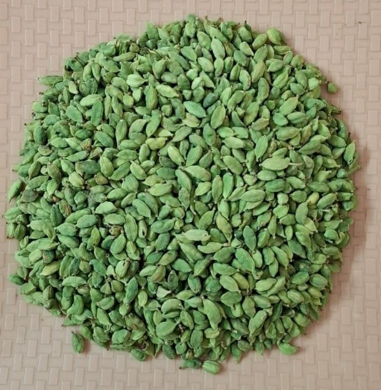

AGS cardamom, sourced from Kerala plantations, is smaller in size but aromatic and flavourful. It is widely used in spice blends, confectionery, and everyday culinary use.

🔑 Key Specifications

• Size: < 6.5 mm
• Colour: Deep green uniform pods
• Volatile Oil: 4–6 ml/100g
• Moisture: ≤12%
• Admixture: ≤2%
• Forms Available: Whole pods, seeds, powder
• Processing: Machine-cleaned, polished, graded

📊 Varnya Grading System

Grade | Size (mm) | Oil (ml/100g) | Moisture (%) | Best For
VX-Premium | 6–6.5 mm | 5.5–6.0 ml/100g | ≤ 10% | Export blends, confectionery
VX-Select | 5.5–6 mm | 5.0–5.5 ml/100g | ≤ 11% | Everyday spice powders
VX-Value | <5.5 mm | 4.0–5.0 ml/100g | ≤ 12% | Budget blends, bulk powders

📦 Packaging Options
• 5 kg, 10 kg, 25 kg vacuum-packed cartons
• 50 kg PP bags (lined)
• Custom packaging & private label available

🧾 Certifications & Compliance
✔️ FSSAI Licensed
✔️ Spice Board RCMC – CRES
✔️ IEC, GST, LUT Compliant
✔️ COA (Oil Content, microbiological, moisture) available on request

🚢 Export Readiness
• Incoterms: FOB / CIF / EXW available
• MOQ: 1-2 MT per grade (customizable for trial orders)
• Lead Time: 10–15 days ex-factory after PO
• Ports: Cochin, Tuticorin
• Transit Time: 7–14 days (UAE / Singapore)

🧾 Lab Report
Available on request (can be shared with buyer upon inquiry).

📩 Contact
Varnya Exports
📧 info@varnyaexports.com
📞 +91-9100913708
🌐 www.varnyaexports.com

