

ccc
Since 2025
Pure. Proven. Global

Product Sheet – Green Cardamom - AGEB

🌶️ Product Overview

Product Name: Green Cardamom – AGEB (> 7 mm)
HS Code: 09083120 (Cardamom, small)
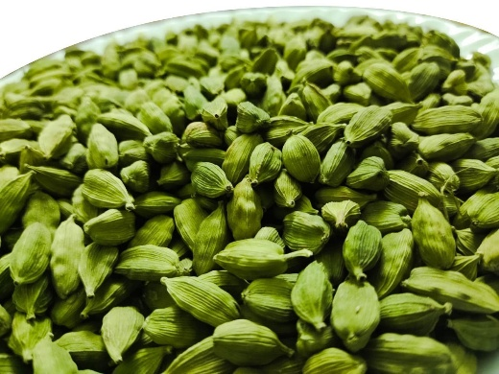
AGEB is the finest grade of Indian green cardamom, handpicked for its extra bold size, rich aroma, and high oil content. It is in high demand in Middle Eastern and gourmet markets.

🔑 Key Specifications

• Size: > 7 mm
• Colour: Deep green glossy pods
• Volatile Oil: 6-8 ml/100g
• Moisture: ≤12%
• Admixture: ≤2%
• Forms Available: Whole pods, seeds, powder
• Processing: Machine-cleaned, polished, graded

📊 Varnya Grading System

Grade | Size (mm) | Oil (ml/100g) | Moisture (%) | Best For
VX-Premium | >8 mm | 7.0–8.0 ml/100g | ≤ 10% | Gourmet teas, premium Middle East buyers
VX-Select | 7.5–8 mm | 6.5–7.0 ml/100g | ≤ 11% | Premium spice blends
VX-Value | 7–7.5 mm | 6.0–6.5 ml/100g | ≤ 12% | Bulk blends, confectionery

📦 Packaging Options
• 5 kg, 10 kg, 25 kg vacuum-packed cartons
• 50 kg PP bags (lined)
• Custom packaging & private label available

🧾 Certifications & Compliance
✔️ FSSAI Licensed
✔️ Spice Board RCMC – CRES
✔️ IEC, GST, LUT Compliant
✔️ COA (Oil Content, microbiological, moisture) available on request

🚢 Export Readiness
• Incoterms: FOB / CIF / EXW available
• MOQ: 1-2 MT per grade (customizable for trial orders)
• Lead Time: 10–15 days ex-factory after PO
• Ports: Cochin, Tuticorin
• Transit Time: 7–14 days (UAE / Singapore)

🧾 Lab Report
Available on request (can be shared with buyer upon inquiry).

📩 Contact
Varnya Exports
📧 info@varnyaexports.com
📞 +91-9100913708
🌐 www.varnyaexports.com

