

ccc
Since 2025
Pure. Proven. Global

Product Sheet – Green Cardomom - AGB

🌶️ Product Overview

Product Name: Green Cardamom – AGB (6.5-7 mm)
HS Code: 09083120 (Cardamom, small)
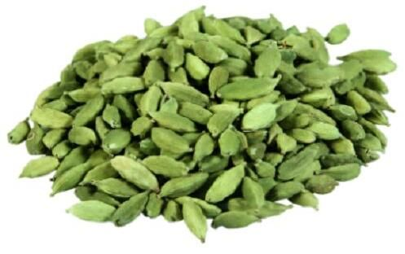
AGB is the most common grade of green cardamom, valued for its bold size, uniform pods, and strong aroma. It is used in spice blends, teas, sweets, and global culinary markets.

🔑 Key Specifications

• Size: 6.5-7 mm
• Colour: Bright green polished pods
• Volatile Oil: 5-7 ml/100g
• Moisture: ≤12%
• Admixture: ≤2%
• Forms Available: Whole pods, seeds, powder
• Processing: Machine-cleaned, polished, graded

📊 Varnya Grading System

Grade | Size (mm) | Oil (ml/100g) | Moisture (%) | Best For
VX-Premium | 6.8–7 mm | 6.5–7.0 ml/100g | ≤ 10% | Premium spice houses, teas
VX-Select | 6.5–6.8 mm | 5.5–6.5 ml/100g | ≤ 11% | Culinary blends, masala powders
VX-Value | 6.5 mm | 5.0–5.5 ml/100g | ≤ 12% | Bulk buyers, confectionery

📦 Packaging Options
• 5 kg, 10 kg, 25 kg vacuum-packed cartons
• 50 kg PP bags (lined)
• Custom packaging & private label available

🧾 Certifications & Compliance
✔️ FSSAI Licensed
✔️ Spice Board RCMC – CRES
✔️ IEC, GST, LUT Compliant
✔️ COA (Oil Content, microbiological, moisture) available on request

🚢 Export Readiness
• Incoterms: FOB / CIF / EXW available
• MOQ: 1-2 MT per grade (customizable for trial orders)
• Lead Time: 10–15 days ex-factory after PO
• Ports: Cochin, Tuticorin
• Transit Time: 7–14 days (UAE / Singapore)

🧾 Lab Report
Available on request (can be shared with buyer upon inquiry).

📩 Contact
Varnya Exports
📧 info@varnyaexports.com
📞 +91-9100913708
🌐 www.varnyaexports.com

